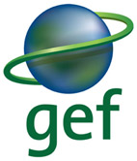
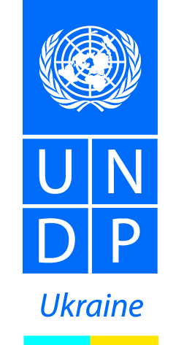

United Nations Development Programme
Country: Ukraine

PROJECT ANNUAL REPORT

UNDP/GEF MSP ‘Integrating Rio Conventions Provisions
into Ukraine’s National Policy Framework’

Atlas Project ID | 74532
Output ID | 00086888
PIMS | 4478
Project Duration | January 2014 – December 2016
Reporting Period | April – December 2014
Total Budget | 900,000

Kyiv, 2014

TABLE OF CONTENT

Acronyms …………………………………………………………………………………..3
I. EXECUTIVE SUMMARY ………………………………………………………………….3
II. BACKGROUND ………………………………………………………………………….4
III. PROGRESS REVIEW ……………………………………………………………………5
Component 1 ……………………………………………………………………………...5
Component 2 ……………………………………………………………………………...6
Component 3 ……………………………………………………………………………...7
IV. PPROJECT IMPLEMENTATION BY OUTPUT……………………………………………..11
V. PROJECT IMPLEMENTATION CHALLENGES AND LESSONS LEARNED……………16
VI. FINANCIAL STATUS …………………………………………………………………..17
VII. ANNEXES ……………………………………………………………………………..20
ANNEX 1. Report on Inception Workshop
ANNEX 2. Report on Kick-Off Conference
ANNEX 3. Minutes of the round table at the Ministry of Energy and Coal of Ukraine (in Ukrainian)
ANNEX 4. Minutes of the round table at the Ministry of Infrastructure of Ukraine (in Ukrainian)
ANNEX 5. Minutes of the round table at the Ministry of Education and Science of Ukraine (in Ukrainian)
ANNEX 6. Minutes of the round table at the Ministry of Agrarian Policy and Food of Ukraine (in Ukrainian)
ANNEX 7. Report on civil servant’s awareness on SD and environmental issues (in Ukrainian)
ANNEX 8. Report on civil servant’s training needs assessment (in Ukrainian)
ANNEX 9. Report on workshop for journalists, 3 June 2014 (in English)
ANNEX 10. Report on broad-based survey (in Ukrainian)

ACRONYMS
CBD UN Convention on Biological Diversity
CCD UN Convention to Combat Desertification
DIM Direct Implementation Modality
GEF Global Environmental Facility
GHG Greenhouse gas
MENR Ministry of Ecology and Natural Resources of Ukraine
NADU National Academy of Public Administration by the President of Ukraine
NIM National Implementation Modality
NGO Non-Governmental Organization
SD Sustainable Development
UNFCCC United Nations Framework Convention on Climate Change
UNDP United Nations Development Programme

- EXECUTIVE SUMMARY

This project is grounded in Ukraine's National Capacity Self-Assessment (NCSA), which was completed in 2007. As with many other countries, Ukraine's challenge in meeting global environmental priorities is rooted in a real priority to meet national socio-economic priorities, lack of awareness on the national benefits of Rio Convention implementation, weak institutional capacities to implement the Rio Conventions, and limited financial resources of government institutions, among other challenges and barriers.
The goal of this project is to catalyze Ukraine's implementation of the three Rio Conventions on a strengthened policy and institutionally sustainable development baseline. To this end, the project focuses on mainstreaming Rio Convention provisions into Ukraine's broader national development framework and strengthening related capacities to implement this framework. The first project objective is to integrate principles and obligations of the three Rio Conventions into Ukraine's national policy framework. Specifically, this will involve the preparation of a national Sustainable Development Strategy (SDS) that fully integrates global environmental priorities. This objective is complemented by a second objective to strengthen key institutional and individual capacities to pursue sustainable development that delivers global environmental benefits. This second objective will take the form of implementation of the SDS at the regional level, training government staff at the local, regional and national levels on the specific interpretation of Rio Convention provisions as they apply to their respective roles and responsibilities to implement associated development policies. This second objective will also be supplemented by a targeted public awareness campaign to raise the understanding of the critical linkages between the Rio Convention principles and the more immediate socio-economic development priorities. Both objectives will be implemented through a learning-by-doing approach. The active participation of stakeholder representatives in the full project life cycle serves to facilitate the strategic adaptation of project activities in keeping with project objectives. The critical role of non-state stakeholders will contribute to the adaptive collaborative management of project implementation.

II. BACKGROUND
The project document was officially signed by UNDP and the Government of Ukraine (Ministry of Ecology and Natural Resources of Ukraine) on 09 December 2013 and was scheduled to start on 29 December 2013 with the Project Inception Workshop. However, in view of the mass peaceful protests (known as Euro-Maidan) that grew and spread throughout the country from November 2013, and due to increased security measures, the project start was postponed until February 2014. The Inception Workshop was thus rescheduled for 25 February. On 19 February the peaceful protests were violently dispersed by the police and throughout 19-21 February more than 100 people were killed in downtown Kyiv. The then president fled the country on 22 February, the acting president was selected, the new Government was formed.
In such conditions the management of UNDP in Ukraine approved the transfer of the project implementation modality from NIM to DIM. A letter informing of this change was sent to the Ministry of Ecology and Natural Resources of Ukraine (MENR) on 22 May 2014. The reasons for such decision by UNDP include, apart from political instability, the lack of regular and productive liaison with the primary national partner – the MENR that was also supposed to coordinate the work with the other seven ministries (to cover all 8 sectors targeted by the project). The ministry’s management was replaced several times over 2014 and its units are being restructured until present. In particular, the State Environmental Investment Agency, which was subordinated to the MENR and which was previously the direct partner of the Project at the MENR, was disbanded in late 2014. To date it is unclear to which department of the MENR this Agency would transfer its functions. It is also worth mentioning, that this was the focal national agency responsible for coordination of implementation of one of the Rio Conventions – UNFCCC.
The Project was launched in Ukraine on 29 April 2014 at the Inception Workshop, which gathered more than 80 representatives of the governmental institutions, academia and NGOs. The detailed presentation of the project goals, activities and milestones was made to the audience. The project management invited all present attendees and other stakeholders to actively contribute to the project implementation by engagement at all stages, provision of feedback and professional support. Representatives of the core national partners – the Ministry of Ecology and Natural Resources of Ukraine and the National Environmental Investments Agency underscored the great value of the activities which are programmed for this project and expressed their full support to its realization.
The presentations which were made by the experts in various sectors of Ukrainian economy demonstrated to the audience the need to urgently review the current policies and normative framework. The latter are outdated, weak and incompliant with the international recommendations and requirements to the environmental protection. The most essential drawback of the acting regulative and legislative system is the lack of linkage between policies of different sectors of economy. And the speakers emphasized that this issue needs to be addressed via reviewing the sectoral programmes and legislation. The complete version of the Inception Report is attached to this Annual Report (ANNEX 1).
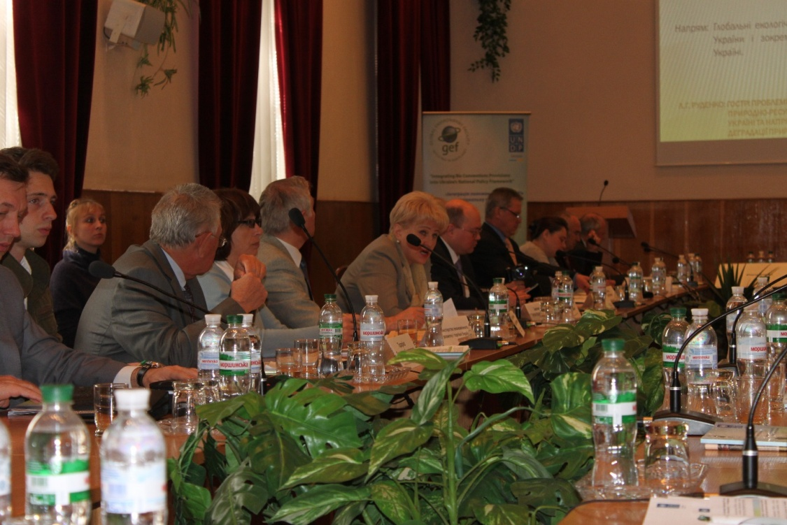
The Project launch at the Inception Workshop on 29 April 2014, Kyiv

III. PROGRESS REVIEW
Component 1: Integrating Rio Conventions into a Sustainable Development Strategy
The initial stage of the Project started in May 2014, when local consultants where enrolled with the aim to carry out analyses of the Ukrainian sectoral policies in terms of their compliance with the international environmental norms, with a particular attention to the provisions of the Rio Conventions, ratified by Ukraine: UN Convention on Biological Diversity, UN CBD (07 Feb. 1995), UN Convention to Combat Desertification, UN CCD (27 Aug. 2002) and UN Framework Convention on Climate Change, UNFCCC (29 Oct. 1996). The consultants were expected to present the reports on the SWOT analyses (analyses of strong and weak points, opportunities and risks) and Gap analyses (analyses of existing shortfalls) with regard to the selected eight sectoral policies. The list of sectors concerned includes: ecology and natural resources management, agriculture, infrastructure, education, transport, social welfare, economic development, energy, regional development and housing.

Each consultant was selected on a competitive basis and had proven expertise and sound work experience in one of the listed sectors. To familiarize the consultants with the essence of the Rio Conventions and the obligations which Ukraine admitted by ratifying them, several consultative meetings were organized with the Rio Conventions Focal Points. The team also gathered for a number of meetings to elaborate the analytical framework for the review process, to make sure that all reports on the analyses conducted are presented in the same format and include all required information. Such a thorough screening of all sectoral programmes and policies with a focus on a certain topic (here - Rio Conventions), held simultaneously in several sectors, is a unique experience, so the team’s task was to develop the framework for the analysis. The International Technical Advisor guided this process and provided the examples from international experience in assessing the national programmes, as well as examples of analytical tools and matrixes.

The consultants carried out desk review of sectoral normative framework in May and June 2014 and presented the first results of their analytical work on July 3, 2014, at the Project’s Kick-Off conference.

The Conference was attended by around 150 representatives of the Ukrainian ministries, research and educational institutions and civil society organizations. The speakers at the plenary sessions included: representatives of the key national partners, Rio Convention Focal Points, UNDP, EU Delegation to Ukraine and all sectoral consultants. The consultants briefly outlined the results of the analyses of sectoral programmes and policies. The parallel thematic sessions were dedicated to each of the three Rio Conventions and they underwent in the form of intensive discussions between the speakers and participants.
The Kick-Off Conference also served as a media event, which informed the general public about the essence and the meaning of the Rio Conventions, as well as the activities planned in the framework of the present Project. A number of journalists from national and local mass media attended the event. The complete report on the Kick-Off Conference proceedings is given in ANNEX 2 to this Report.

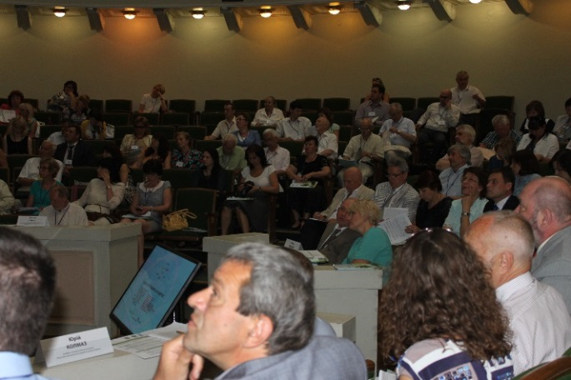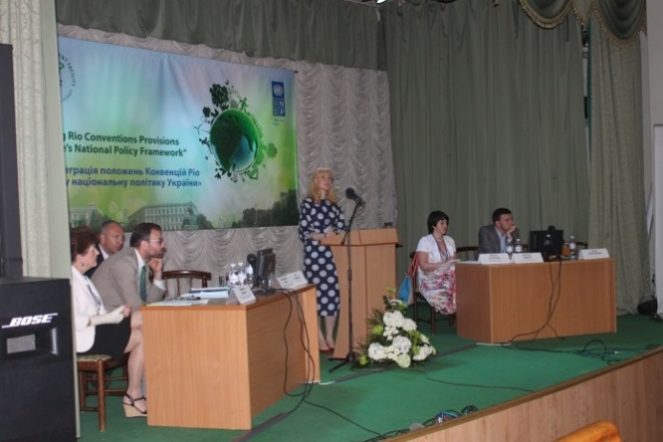
The Kick-Off conference on 3 July 2014, Kyiv

The reports on the sectoral analyses were then further reviewed and commented by the peer experts representing corresponding sector. The feedback from at least 10 reviewers per each analysis was obtained (overall more than 80 peer reviews were engaged from all sectors of economy and from all parts of Ukraine to provide comments and recommendations into the SWOT and Gap analysis). Their comments were further studied by the sectoral consultants and the recommendations were integrated in the corresponding reports. In 2014, the Project managed to convene 4 of 8 presentation/discussions of the completed sectoral analysis at the relevant ministries. These are: the Ministry of Energy and Coal of Ukraine (Minutes of the round table are in ANNEX 3, in Ukrainian); Ministry of Transport and Infrastructure (ANNEX 4, in Ukrainian); Ministry of Education and Science (ANNEX 5, in Ukrainian); Ministry of Agropolicy and Food of Ukraine (ANNEX 6, in Ukrainian). All the four round tables were chaired by Deputy Ministers (from respective ministries) and turned out to be productive: the Project experts made a brief overview of obligations of Ukraine under the Rio Conventions and the presentation of the sectoral analysis of the implementation of the Conventions in the corresponding sector. Ministries staff from relevant departments provided comments and agreed to continue further cooperation with the project experts to follow-up on the gaps in policies revealed during the analysis.

The remaining similar round tables (at the rest of target ministries) are expected in early 2015. The delay is from the ministries’ side – some of them are experiencing essential staff reduction, some – restructuring, others do not view the Rio Conventions as a priority for the ministry at this instable time for the country (e.g., Ministry of Social Policy of Ukraine).

Component 2: Developing Institutional and Technical Capacity

The second component of the Project focuses on the enhancing of institutional capacities of the stakeholders to implement the Rio Conventions and to contribute to the country’s sustainable development. This will be achieved through the engagement of the ministries staff and stakeholders in the discussions on the revealed gaps in the active sectoral legislation and programmes and ways to improve and update them.

One of the Project’s primary partners under this activity is the National Academy of Public Administration by the President of Ukraine (NADU). This national educational institution is providing exclusive professional training for civil servants. In 2014, the Project implemented together with NADU a number of activities. First of all, the Project organized the survey of the government staff awareness on the issues of environmental policies, on the pre-requisites for the country’s sustainable development (SD), on the applicability and meaning of the Rio Conventions for Ukraine. The assessment was done among 300 students of the NADU through questionnaire forms, which were developed and then analyzed by the Project’s consultant – Environmental Sociologist. The expert concluded that the majority of respondents lack understanding of the notion ‘SD’ and do not recognize the linkage between the social, economic development and the environmental protection. They also rated the national environmental programme and management as weak and with low effectiveness. Among other gaps the respondents named lack of cooperation between different ministries in issues related to environmental protection. The report on this survey and the questionnaire form are in ANNEX 7 (In Ukrainian).
In order to develop a training module for civil servants to be introduced into the curriculum of NADU, the Project undertook a separate Training Needs Assessment. The Assessment was based on a survey of additional 140 civil servants of all levels (deputy ministers, heads of departments, governors, head of regional administrations, mayors, heads of units at local authorities, etc.).
The Training Needs Assessment revealed that the identified knowledge gaps are to be addressed by introducing additional training modules focusing on both theory and practical skills. The results of the survey will be used to design, in consultations with the NADU, a training programme and learning materials (on public administration for SD), with the ultimate aim to raise the target audience’s capacities to develop and implement integrated global environmental and SD strategies at the national, regional and local levels. The report and the questionnaire form are in ANNEX 8 (in Ukrainian).

On 26 November 2014 the Project organized together with NADU a conference ‘Public Administration: Development Trends’, which gathered around 200 delegates from all around Ukraine. In her welcome remarks, UNDP DRR Inita Paulovica noted: ‘Considering the importance of public administration in the creation of a favourable environment to foster economic growth, social cohesion and environmental protection – the three pillars of sustainable development, reinventing and reforming public administration is a positive and necessary way forward.’
A separate thematic session at this conference was devoted to the ‘Integration of the Basic Principles of Sustainable Development in Public Administration’.
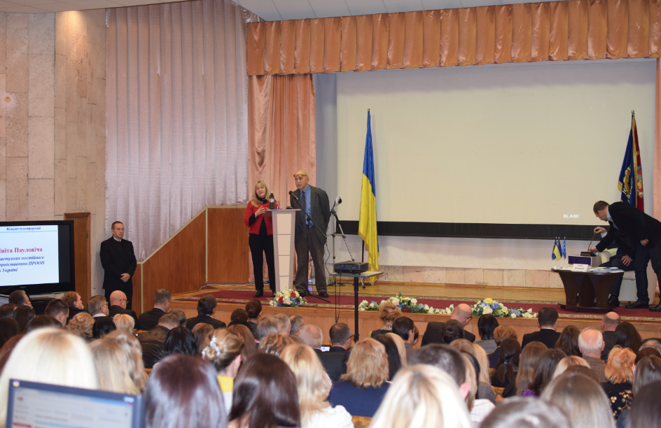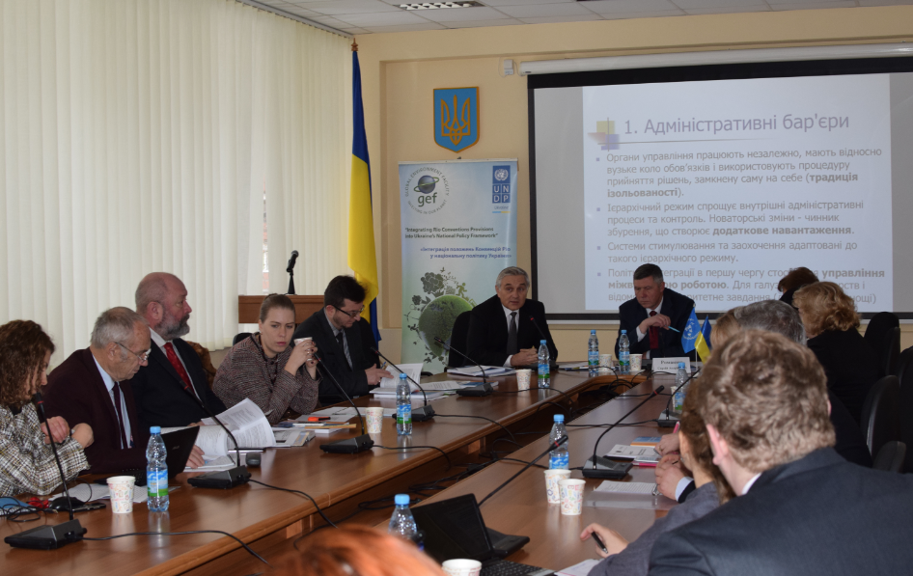
Plenary and thematic session at the conference ‘Public Administration: Development Trends’ on 26 November 2014, Kyiv
On 27 November 2014, the Project’s International Technical Specialist, Mr. Kevin Hill, delivered a lecture for the students of the NADU. He outlined the principles of adaptive collaborative management as an approach to effective environmental governance.
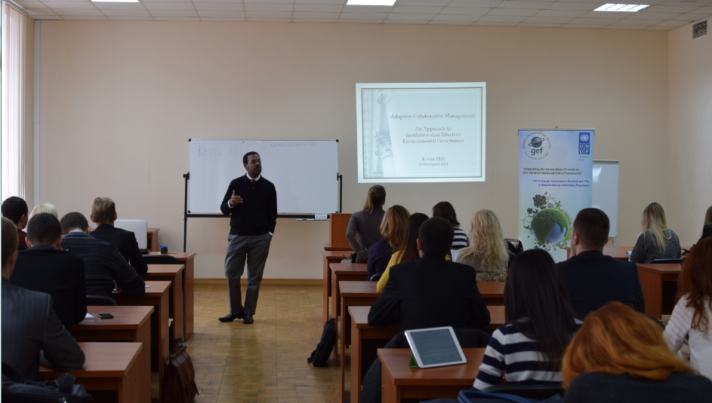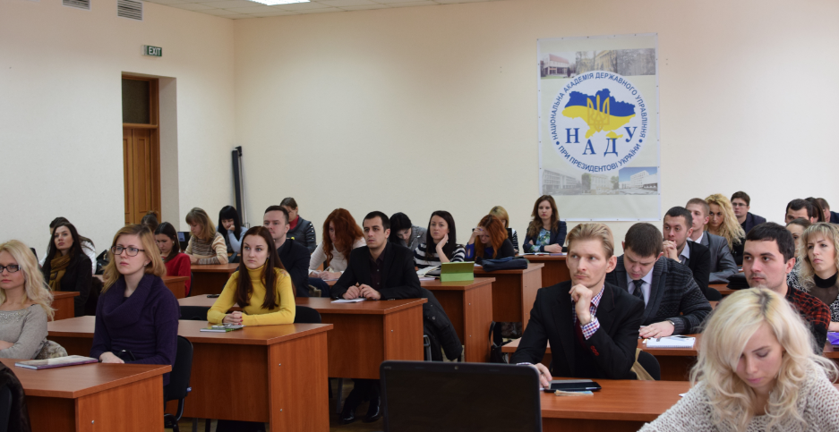
Lecture for civil servants at the NADU on 27 November 2014, Kyiv
Component 3: Enhancing Awareness and Understanding of the Environment's Contribution to Socio-Economic Development, with Particular Reference to the Rio Conventions
The third component of the Project aims at raising the knowledge of the Rio Conventions provisions and their meaning for Ukraine. The Project developed a detailed Communications Strategy and identified the key targets and interventions. It will serve as a baseline for designing annual plan of activities under this component.

In 2014, the Project implemented a number of awareness raising activities. Among them – learning sessions for the journalists who focus on environmental issues and topics related to the sustainable development. The first training of the series was organized on 3 June 2014 in Kyiv. The Project consultants made presentations about the key environmental challenges for Ukraine, about the place of ecology in shifting to the sustainable development model, and on the relevance of the Rio Conventions for Ukraine.

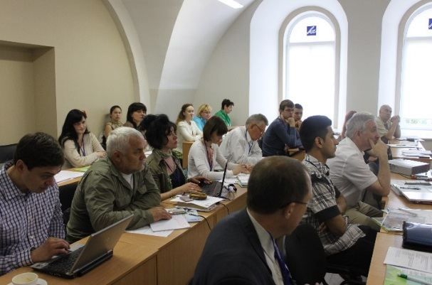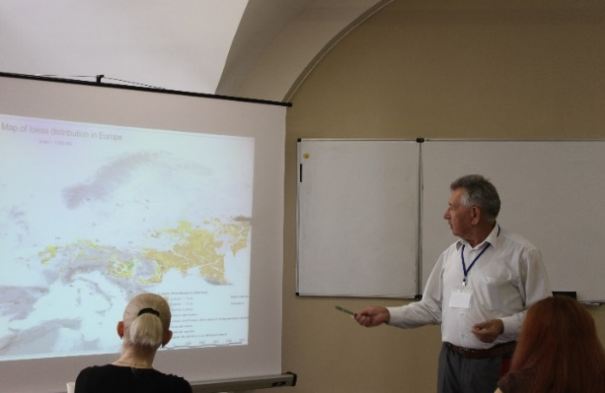
The academician and expert in agrarian sector makes a presentation for journalists on 3 June 2014, Kyiv

The training was based on interaction between the presenters and the participants. The latter were asked to fill in questionnaire forms to enable assessment of the journalists’ knowledge on the subject. The results revealed lack of understanding of the linkage between social, economic and ecological components of the sustainable development and zero knowledge of the Rio Conventions and their relevance for Ukraine. The Report on the workshop is provided in Annex 9.

On 31 October 2014, the project convened another workshop for journalists. This time it was organized in a form of a study tour to the ‘Agroecology’ Farm (Mykhailyky village, Poltava oblast). The farm owners have been practicing organic agricultural production for more than 40 years. The basic requirements to the organic technologies include: ultimate rejection of harmful fertilizers, herbicides, pesticides, mineral fertilizers and other chemical substances. Instead, organic substitutes are applied – humus, green manure. This makes agricultural production environmentally friendly, and at the same time the products are ecologically clean, while the enterprise is highly lucrative. The agrarians shared with the journalists their experience of using soil protecting technologies as well as principles of rational land management.
The journalists got to know why efficient natural resources management, such as land management, is essential to ensure sustainable development of the nation. It is well known, that the core principle of sustainable development lies in the approach which provides for meeting the needs of the present without compromising the ability of future generations to meet their own needs. The journalists expressed high interested to the subject and posted a number of publications in local and national mass media.
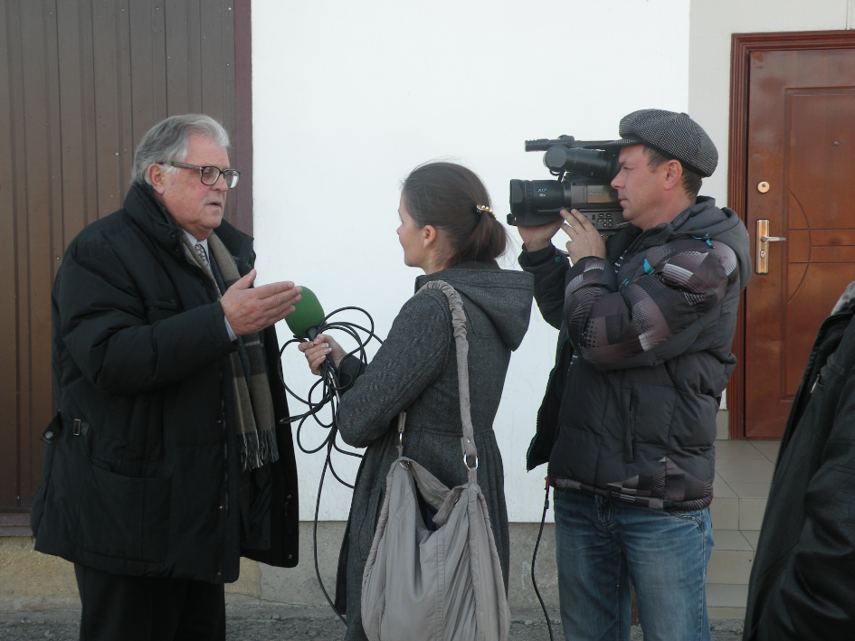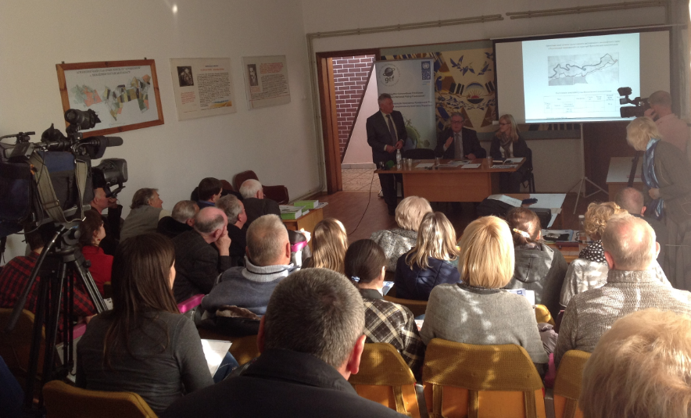

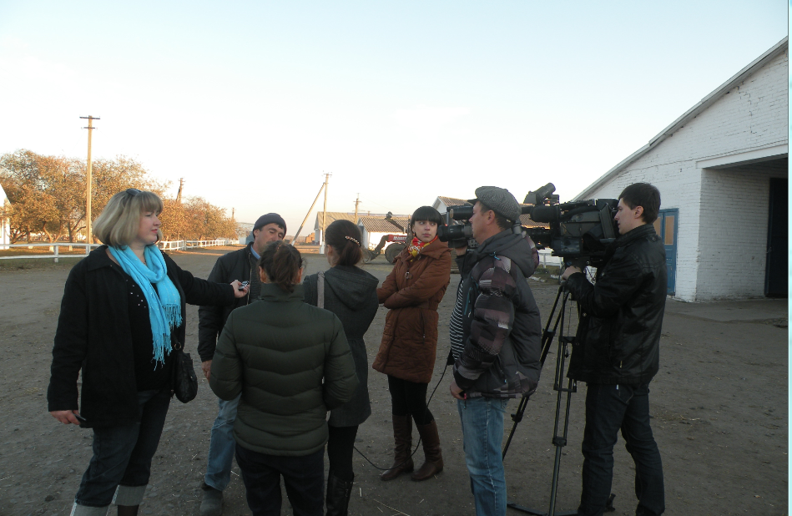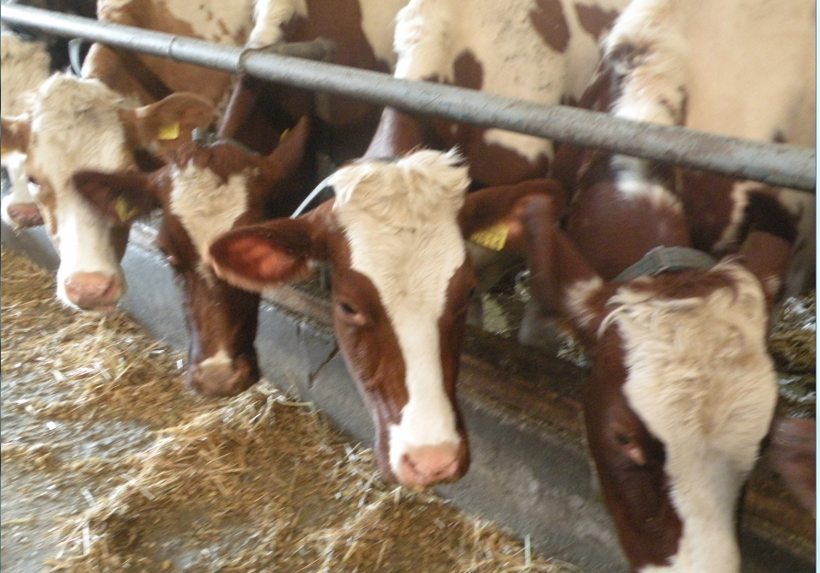
The study tour to the farm revealed an intense interest of journalists to organic and clean production of agricultural products, 30 October 2014, Mykhailyky village, Poltava oblast

On 8-9 October 2014, the Project co-facilitated the International Forum for Sustainable Business Development ‘Green Mind’, which was convened in Kyiv. UNDP DRR Inita Paulovica has addressed the business representatives at the opening session, saying that ‘Governments alone cannot drive a global transformation, business solutions cannot scale on their own to meet global needs, and civil society cannot achieve sustainable development in isolation. Only mutual actions can put the world on a sustainable track… The private sector can therefore play a critical role for green growth both in the formal and informal sectors and thus in poverty eradication, environmental responsibility and social welfare’.

The third component envisaged carrying out a nation-wide survey to identify the initial level of knowledge of the global environmental issues, basic notions of the SD, understanding of the linkage between environment and development, and the issues addressed by the Rio Conventions. The results of the survey serve as a baseline and are used for planning of consecutive awareness raising measures under this project. A similar survey will be conducted at the project end, to assess the impact of project activities (6 months prior to the project completion). Data collection was performed in August 2014 by the polling company GfK, while the questionnaire form was designed by the Project, in consultation with the Environmental Sociologist, who then undertook the statistical and sociological analysis of the responses. The expert revealed that the majority of respondents admit that environmental protection is one of the priority areas for Ukraine. The level of awareness of factors that cause land degradation, climate change and loss of biodiversity is comparatively high. Many respondents provided correct answers to these questions. However the sociologist considers that the major source of information for the general public is mass media and thus their understanding of global and local environmental issues are influenced by the way the journalists cover these topics, and, accordingly, on the awareness level and competence of the journalists. The expert states that comparing to responses of Ukrainians to similar questions back in early 2000, the level of personal environmental responsibility has risen essentially. However, these responses refer to the respondents’ attitude to the problem rather than real actions undertaken to improve the state of the environment. The Ukrainian version of the report is available in ANNEX 10.
On 17 November 2014, the Project’s Environmental Sociologist, O.Stegnii, gathered the students of the Faculty of Ecology at the National University ’Kyiv Mohyla Academy’ to present the results of the broad-based survey. The students expressed keen interest in the subject and asked many questions. The report will be finalized and published in 2015.

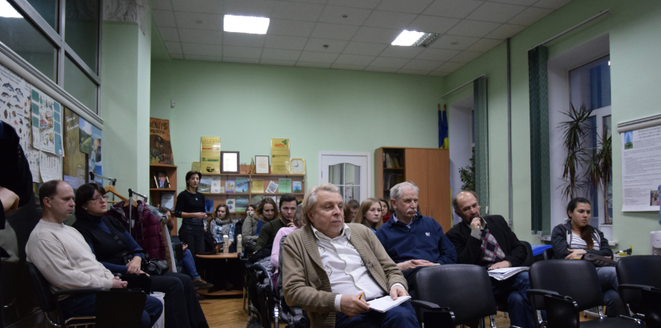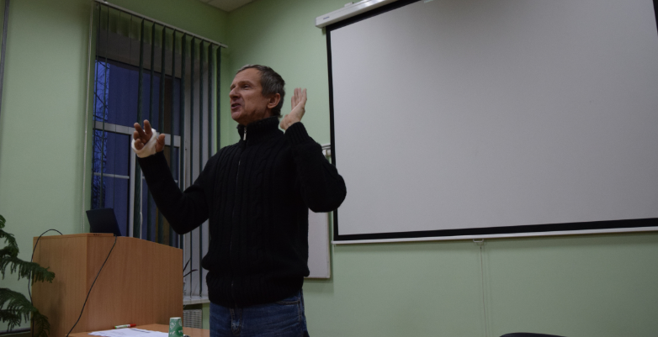
Environmentalists-to-be and the Faculty’s professors learn about the general public perceptions of environmental issues (presentation of the survey on 17 November 2014, Kyiv)

In November 2014 the Project co-organized another social event – nation-wide annual contest of social advertisement among students. The Project announced a contest of video footages and posters in nomination ‘Sustainable Development’. In response to this call, the Project received more than 50 works from future PR specialists. Many of them produced good products, even though the multifold nature of the notion ‘SD’ makes it hard to explain in a single image or a 30-second video. The winners were identified by UNDP. The initiative has proven to be interesting and will continue throughout the project duration.

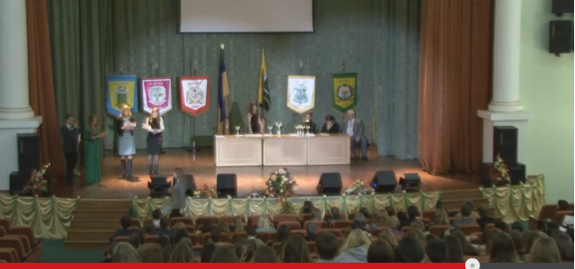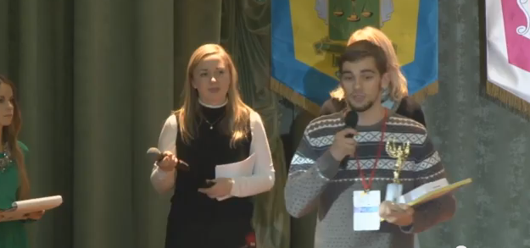
The awarding ceremony was a culmination of the contest of social ad among students (23 November 2014, Kyiv)
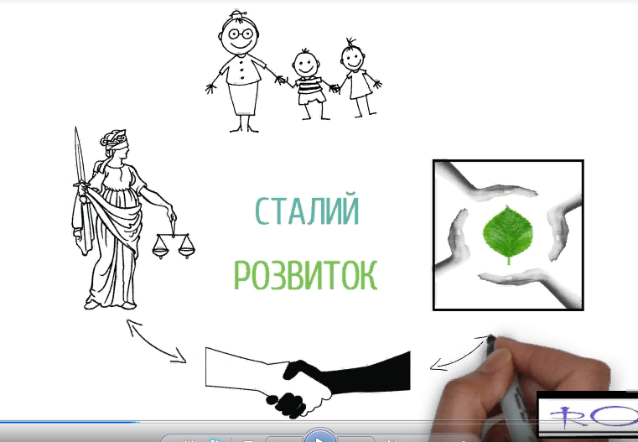
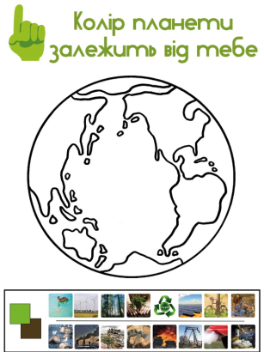
The contestants used various techniques to deliver the message in short video footages
It was uneasy task to reflect the meaning of ‘sustainable development’ in a poster
The Project engages Interns who are interested in the Project’s interventions and their primary task is to regularly post messages at the Facebook page created for the Project (‘Sustainable Development for Ukraine’, here is a link: https://www.facebook.com/bioundp). The Project team will reach for the general public with the news about the Project progress, interesting facts about the environment protection and some information which is relevant in the view of the Rio Conventions. The Facebook page’s content will be concise and easy to understand for the wider audience, and it will include interactive communication (for example, online surveys).

The Project also developed and printed a short informational booklet on ‘Sustainable Development’, providing basic facts about the subject:
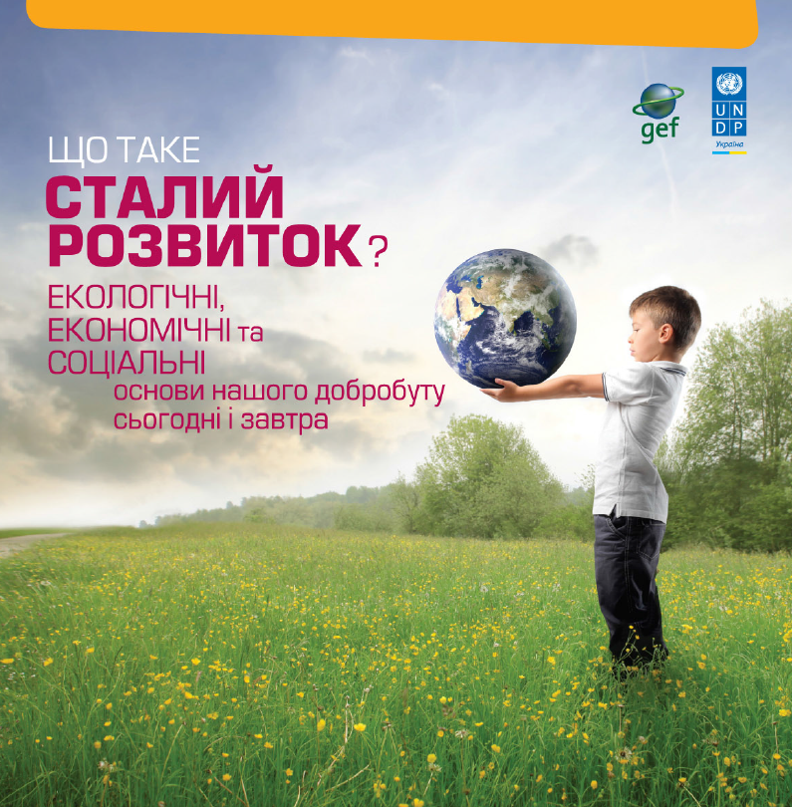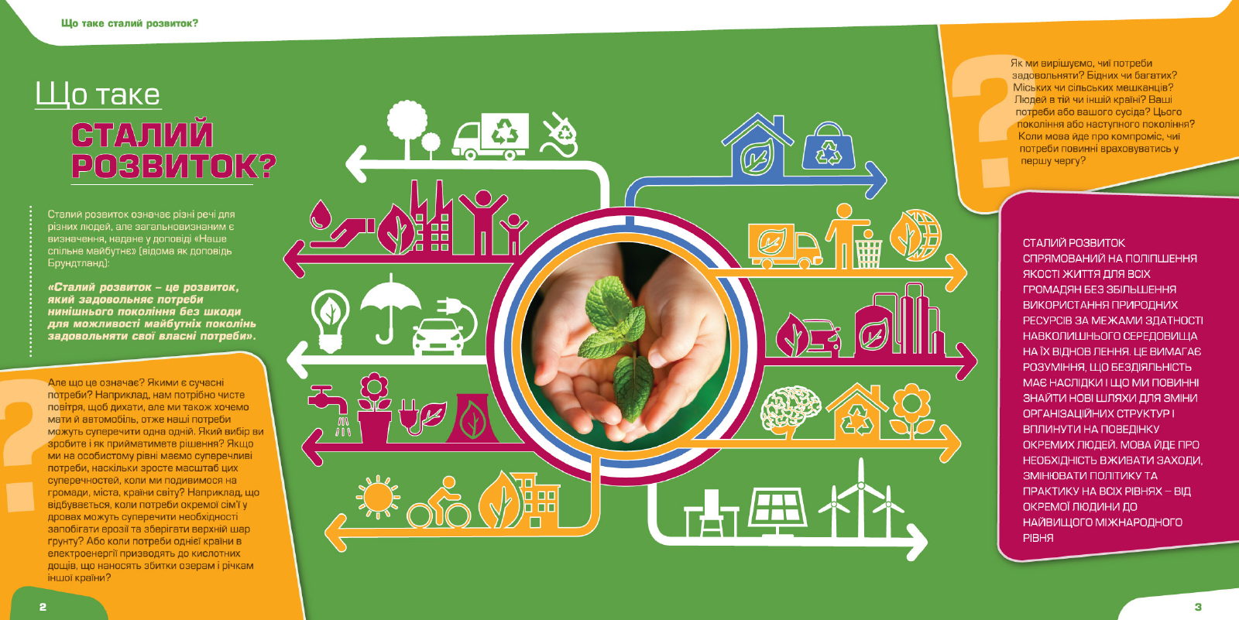

IV. PROJECT IMPLEMENTATION BY OUTPUT
Output |  | Activities | Status of implementation
Outcome 1: Policies and institutions catalyze the mainstreaming of the Rio Convention principles and obligations into sectoral policies
Output 1.1  SWOT and Gap analysis of Ukraine's policy framework and institutional implementation of Rio Conventions |  | - Analytical framework report for Rio Convention mainstreaming | - Completed: Analytical framework for the sectoral analyses was developed
 |  | - Eight (8) sectoral analytical reports containing detailing opportunities for mainstreaming Rio Conventions | - Completed: Draft analytical reports are submitted to UNDP by the sectoral consultants and they will be finalized after getting the feedback from the corresponding ministries
 |  | - At least 10 peer review comments submitted for each sectoral analysis | Completed:  - The framework for assessing and rating the analytical reports by the peer reviewers is developed  - Rating and comments from peer reviewers integrated into reports by the sectoral consultants
 |  | - High quality rating of all eight completed sectoral analyses rated by peer review experts | - Completed
 |  | - Each constituent public dialogue/ council is attended by at least 50 diverse representatives from the target stakeholder constituency | - Scheduled for March-April 2015. The platform meetings will follow the round tables at the ministries
Output 1.2:  Draft Sustainable Development Strategy articulates a holistic vision and programmatic approach to policy and legislative reforms that catalyze Rio Convention implementation |  | - Draft SDS is prepared  - Key stakeholders actively participated in the drafting of the integrated SDS  - Assessment report of guidelines, tools, and resources to facilitate implementation of sectoral policies, plans, and programmes and legislation  - Official Endorsement of recommended policy and legislative reforms by independent experts, decision-makers, and key stakeholder representatives  - At least 20 peer review comments submitted from diverse independent experts  - High quality rating of draft SDS by peer review experts | - Activities under this Output are scheduled for Years 2 and 3 according to the Work Plan
Outcome 2: Capacities developed to implement Rio Conventions through national and regional SDS implementation
 | Output 2.1:  Learn-by-doing mainstreaming of Rio Conventions into selected sectoral policies, plans, programmes, and legislation at the regional, national, and local levels | - Four sets of high priority Rio Convention mainstreaming recommendations from the eight sectoral analyses are selected for targeted implementation at the regional, national, and local levels | - The project team developed a plan of joint activities with the NADU, including professional training for the civil servants in Ukraine  - The NADU facilitated the survey on the awareness of civil servants of understanding of key environmental challenges, sustainable development priorities and the basic notions of the Rio Conventions  - Joint awareness raising activities in regions are planned for late 2015
 |  | - All selected Rio Convention mainstreaming recommendations are completed within a 12 month period | - Scheduled for Year 2
 |  | - Independent evaluation of targeted mainstreaming activities, best practices, and lessons learned | - Scheduled for Year 3
 | Output 2.2:  Draft SDS Roadmap for the effective integration and institutionalization of Rio Convention provisions into sectoral policies, plans, programmes, and legislation | - Draft SDS Roadmap document is prepared  - SMART indicators to measure SDS Roadmap implementation are developed  - Specific structures and arrangements for national SDS implementation are recommended for regional and central government consideration  - At least 20 peer review comments submitted from diverse independent experts  - High quality rating of draft SDS Roadmap by peer review experts | - Scheduled for Years 2-3

Outcome 3: Enhanced awareness and understanding of the environment's contribution to socio-economic development, with particular reference to the Rio Conventions
Output 3.1:  Kick-Off Conference | - One-day Kick-Off Conference raises high profile of Rio Convention mainstreaming into sectoral policies, plans, programmes, and legislation through a series of eight (8) sectoral panel discussions | - Completed
Output 3.2:  Broad-based survey on public awareness | - Analysis of the public awareness and understanding of the link between environment and development (report) | - Completed  - The report on the survey to be published in 2015
 | - Improved awareness and understanding of the value of mainstreaming Rio Conventions within sectoral policies, plans, programmes and legislation | - Scheduled for Years 2-3
Output 3.3:  Public awareness campaign | - Comprehensive public awareness plan developed to detail the content and distribution of materials and media | - Completed
Output 3.4:  Public awareness and educational materials | - Articles on Rio Convention mainstreaming in popular literature | - Completed: the project’s consultants published articles in professional printing digests  - The project seeks opportunity to produce 30-second video to be placed on TV channels and in cinemas
 | - High school competitions on links between local behaviour and the global environment | - The project is developing the concept of the competitions and will announce them in March 2014  - The Project announced a contest of social advertisement among students. The winners were identified in November 2014
 | - High school education modules and accompanying lecture material on the global environment | - In progress: the Consultant is developing the structure of the module
Output 3.5:  Awareness-raising dialogues and workshops | - Media awareness workshops on Rio Convention mainstreaming | - One workshop aimed at raising journalists awareness of the sustainable development and Rio Conventions held on June 03, 2014  - One study tour for journalists to the farm practicing organic agriculture was organized on October 30, 2014
 | - Expert panel discussions on synergies between Rio Conventions and business  - Annual public constituent meetings on Rio Convention mainstreaming  - Regional sensitization of Rio Convention mainstreaming and SDS implementation  - Increased sensitization and understanding on Rio Convention mainstreaming values | - Pending
Output 3.6:  Training of government staff on Rio Convention mainstreaming | - Comprehensive training programme on Rio Convention mainstreaming integrated within National Academy of Public Administration (NAPU) trainings  - Number of government staff and stakeholder representatives that participated actively in learn-by doing Rio Convention mainstreaming through activities 1.2.1, 1.2.2, 2.1.3, 2.1.4, 2.1.5, and 3.3.1  - SDS training workshops carried out at the regional and national levels  - Rio Convention Focal Points endorse SDS implementation | - In progress: agreement reached with the NADU on preparation of the training programme
Output 3.7:  Internet visibility of Rio Convention mainstreaming | - Website promotes Rio Convention mainstreaming  - Facebook page on Rio Convention mainstreaming | - The Website Designer is contracted; the website to be launched in early February 2014. Materials to be placed on the website are being collected  - Facebook page is operational since July 2014; news about the environmental protection, sustainable development and project activities are posted a few times a week

V. PROJECT IMPLEMENTATION CHALLENGES AND LESSONS LEARNED
Lessons learned while implementing the listed project activities are presented below.

Major achievements:

- The Project has made a great breakthrough straight from the start in 2014: the sectoral consultants guided by the Project carried out comprehensive SWOT and Gap analyses in eight sectors of national economy – screened all essential normative and legislative acts to identify the gaps in meeting the provisions of the Rio Conventions and proposed recommendations. This task was completed within a few months only, while the consultants had to come up with a single framework for this study, learn the obligations under the Rio Conventions, which are specific and applicable for each sector in question, then compile a list of all essential sectoral policies and programmes and perform the analysis. It is worth noting that initially the consultants had little knowledge of the obligations under the Rio Conventions, through which the policies had to be screened;
- Further, the reports on SWOT and Gap analyses were peer-reviewed by more than 80 experts, who provided their assessment, comments and recommendations, and thus ensured the quality of the final reports. This was done on a pro-bono basis, which makes their input even more valuable, as this demonstrated the peer reviewers’ commitment to contribute to the improvement of current governance in issues related to the country’s SD;
- In the process of the sectoral policies review and further discussions of the results at the ministries and other public platforms the Project stimulates awareness of the Rio Conventions and SD;
- Ongoing communication with relevant national partners and key stakeholders reveals great support to the Project activities, which means that these initiatives are very beneficial to the country. Above all, as the result of these activities, a better interaction between the various ministries and stakeholders can be reached;
- By organizing round tables, workshops, study tours, etc. the Project not only reaches the main purpose of the event, but also creates media events – in all cases the activities were covered in mass media, including the websites of the partner ministries and the Cabinet of Ministers website.

Barriers:
- The project was initially designed for the implementation under the Nationally Implemented Modality (NIM). However, the reality and current political situation in Ukraine necessitated the shift to the Directly Implemented Modality (the project activities are executed by UNDP, in close interaction with the national partners). This should help avoid barriers and risks, which may occur for projects under NIM
- The Project was launched at the time when Ukraine was in the active stage of both political and economic crises, which was the reason for the delays in timely delivery of the tasks. The political instability also means continuous changes of the ministries staff, thus creating difficulties in establishing sustainable communication with the government. In particular, this is the reason for delays with organizing round tables at the ministries to present the sectoral analyses. These delays, in turn, provoke postponement of other project activities
- The sectoral analysis is a comprehensive study, which requires more time than programmed under the project. Sectoral analysis undertaken through SWOT and Gap methodologies was a new exercise for the Consultants and the ministries’ staff, which nevertheless has become a kind of beneficial learning component and added to other capacity development activities of the project.
- To cover the whole complex of obligations that Ukraine bears in connection with ratification of the Rio Conventions, it is also worth to explore the gaps in meeting the requirements of essential protocols supplementary to the Rio Conventions – the Cartagena Protocol on Biosafety (2003), Kuala Lumpur Supplementary Protocol on Liability and Redress to the Cartagena Protocol on Biosafety (2012), the Kyoto Protocol to the UN Framework Convention on Climate Change (2004). The timeframe and the design of the present project do not envisage these studies.
- The Rio Convention Focal Points are responsible for the implementation of the Conventions in Ukraine. They accumulate the facts and figures related to this issue and should serve as the key advisors to the Project and guide the sectoral analyses. Since they are civil servants, UNDP cannot contract them to benefit from their expertise. Nevertheless, the Projects makes sure to involve them in all public events as an in-kind contribution from the Ministry of Ecology and Natural Resources.
- Payment of even a small honorarium to 80 peer reviewers was not possible, as contracting so many additional ICs was against the Project Document AWP.

VI. FINANCIAL STATUS
This Project is a middle-size project implemented by UNDP. The project is designed in a way to ensure proper and regular involvement of key national agencies and counterparts throughout the whole Project cycle, who provide significant in-kind contribution to the project.
In 2014 the Project absorbed USD 158.595, which is 50.1% of the programmed amount (USD 316,500). The savings occurred for a number of reasons listed below:
- The Project started with a five-month delay due to the political instability and mass unrest in Ukraine, which started in December 2013 and gradually intensified throughout 2014
- As a result of the 100% currency devaluation, the dollar equivalent of the payments made in the Ukrainian currency (hryvnia) was much lower than budgeted
- A few activities were shifted to 2015 (e.g., platform discussions, regional mainstreaming activities, etc.) due to delays from the partner ministries’ side, which are to host these meetings

The funds that were not used in 2014 are transferred to 2015.
Financial analysis per components shows that the delivery rate in 2014 was as follows:
Component 1 – 34%; Component 2 – 69%; Component 3 – 55%.
In the structure of expenditures in 2014 the costs are distributed as shown below:

Please refer to the report on the amounts spent in 2014 as per activities and budget lines in the Project Budget Balance sheet below.

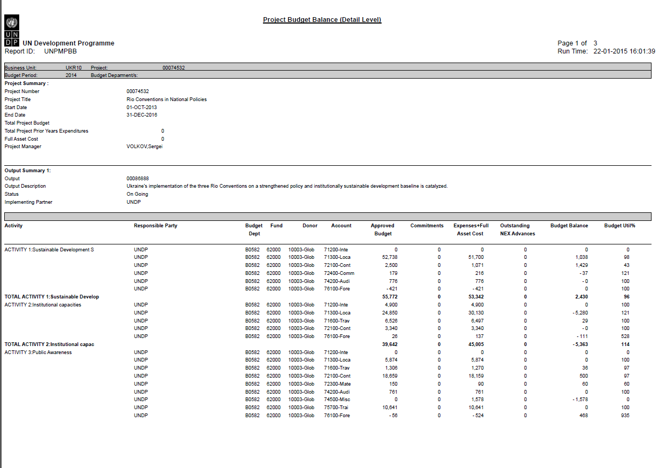
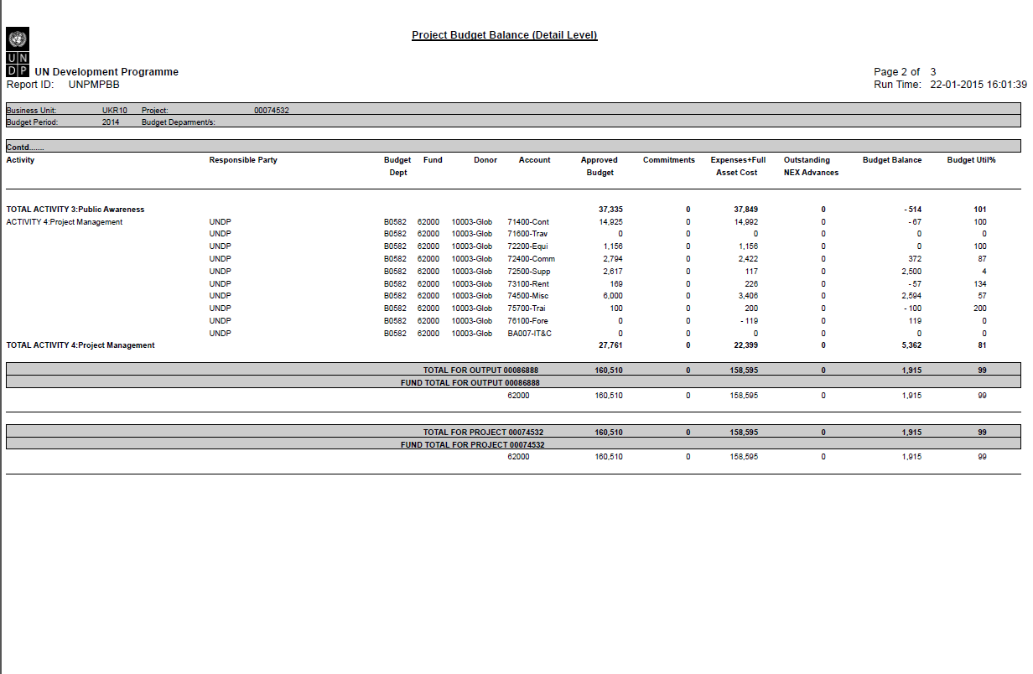

VII. ANNEXES
ANNEX 1. Report on Inception Workshop
ANNEX 2. Report on Kick-Off Conference
ANNEX 3. Minutes of the round table at the Ministry of Energy and Coal of Ukraine (in Ukrainian)
ANNEX 4. Minutes of the round table at the Ministry of Transport and Infrastructure of Ukraine (in Ukrainian)
ANNEX 5. Minutes of the round table at the Ministry of Education and Science of Ukraine (in Ukrainian)
ANNEX 6. Minutes of the round table at the Ministry of Agrarian Policy and Food of Ukraine (in Ukrainian)
ANNEX 7. Report on civil servant’s awareness on SD and environmental issues (in Ukrainian)
ANNEX 8. Report on civil servant’s training needs assessment (in Ukrainian)
ANNEX 9. Report on workshop for journalists, 3 June 2014 (in Ukrainian)
ANNEX 10. Report on broad-based survey (in Ukrainian)

Each analysis was circulated for peer review to at least ten (10) national experts, who used a set of 9 criteria to rate the analyses.

